1. Body Fat %
If you’re not able to take your body fat measurements, or have someone else do it, then skip this step and move onto number 2.
2. When taking your measurements, use the following guidelines:
• Shoulders: Around the centre of the shoulders (tape should go around your chest and your back)
• Chest: At nipple level and under the arms (tape should go around your chest and your back)
• (Either right or left Arm) Arm: Around the largest circumference between elbow and shoulder
• Waist: Around midsection over the belly button
• Hips: Around your hips. One hand-width below the belly button (close-fingered)
• (Either right or left Thigh) Thigh: Just below buttocks
• (Either right or left Calf) Calf: Around largest point between knee and ankle
3. Resting Heart Rate (RHR)
Make sure you're sitting at rest for at least 5 or more minutes to ensure accuracy. The best time is to take your resting heart rate is when you first wake up, when you take repeat measurements of your RHR make sure you do it at the same time of the day on each occasion.
You want to make sure that a. You haven't had caffeine, within the last several hours previous to taking your RHR. And that you don’t take your RHR after exercise.
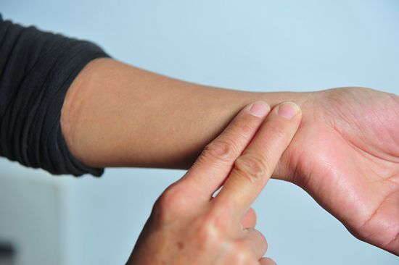
Using your index and middle finger, count the number of beats you feel in 60 seconds. Do not use your thumb since it has a light pulse that can confuse you while counting. Test over 3 days and record an average reading.
If you get distracted counting for 60 seconds then use this option. Count the number of beats you feel in 10 seconds. Multiply the number of beats you count in 10 seconds by six to find the number of beats per minute. You can take your pulse three times, then take the average rate of all three to be super scientific.

 | Before You Start Your Program | 4 weeks after you’ve started your program | 8 weeks after you’ve started your program
Date:
Body Fat %
Shoulder Measurement
Chest Measurement
Arm
Waist
Hips
Thigh
Calf
Resting Heart Rate

